**JAVA TEST(22.07.24)**

**1.** **CREATE AN ARRAY LIST AND ADDING THE ELEMENTS TO THE LIST LION TIGER CAT DOG**

**BY ADDING AN ELEMENT AT PARTICULAR INNDEX AND USE FOR EACH LOOP TO DISPLAY ALL THE ELEMENTS IN THE ARRAY.**

import java.util.ArrayList;

public class array{

public static void main(String[] args){

ArrayList<String>animals=new ArrayList<>();

animals.add("lion");

animals.add("tiger");

animals.add("cat");

animals.add("dog");

animals.add(2,"elephant");

System.out.println("Elements in the array:");

for(String a:animals){

System.out.println(a);

}

}

}

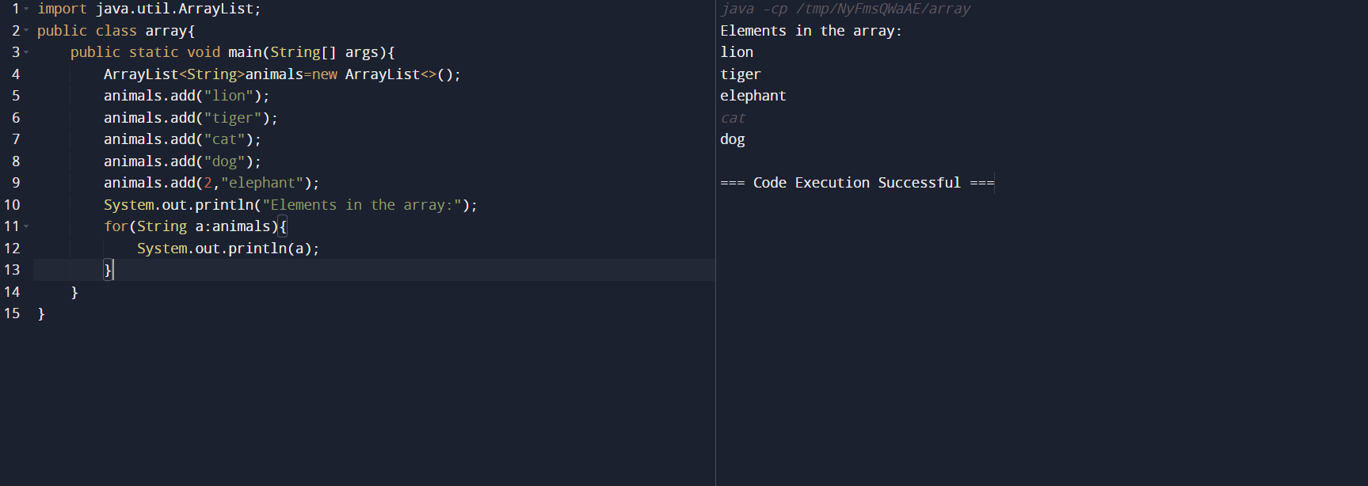

**2.** **CREATE ARRAY LIST TO INSERT NUMBERS 2,4,5,6,8,9AND DEMONSTRATE SIZE OF ARRAY LIST DEMONSTRATE GET AND SET METHOD.**

import java.util.ArrayList;

public class ArrayListExample {

public static void main(String[] args) {

ArrayList<Integer> num= new ArrayList<>();

num.add(2);

num.add(4);

num.add(5);

num.add(6);

num.add(8);

num.add(9);

System.out.println("Size of ArrayList: " + num.size());

System.out.println("Element at index 3: " + num.get(3));

num.set(2, 10);

System.out.println("Updated element at index 2: " + num.get(2));

System.out.println("Elements in the ArrayList:");

for (int n: num) {

System.out.println(n);

}

}

}

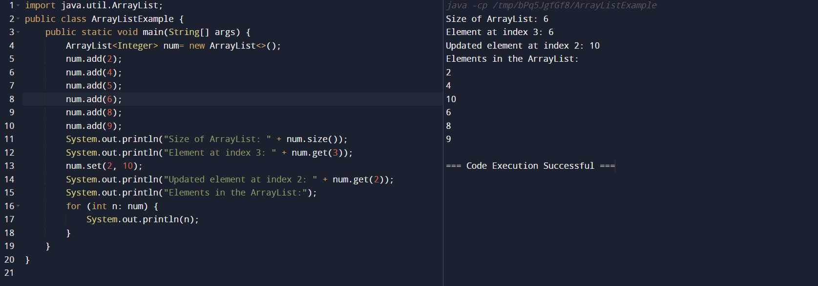

**3.** **CREATE THE ARRAY LIST WITH ELEMENTS C, C++, JAVA, PYTHON, RUBY, JAVASCRIPT, DEMONSTRATE THE FOLLOWING REMOVE ELEMENT FROM A PARTICULAR INDEX**

import java.util.ArrayList;

public class ArrayListRemoveExample {

public static void main(String[] args) {

ArrayList<String> lang=new ArrayList<>();

lang.add("C");

lang.add("C++");

lang.add("JAVA");

lang.add("PYTHON");

lang.add("RUBY");

lang.add("JAVASCRIPT");

System.out.println("Original ArrayList:");

System.out.println(lang);

System.out.println();

int indexToRemove = 3;

if (indexToRemove >= 0 && indexToRemove < lang.size()) {

String removedLanguage = lang.remove(indexToRemove);

System.out.println("Removed element at index " + indexToRemove + ": " + removedLanguage);

System.out.println();

} else {

System.out.println("Index out of bounds. No element removed.");

System.out.println();

}

System.out.println("Updated ArrayList:");

System.out.println(lang);

}

}

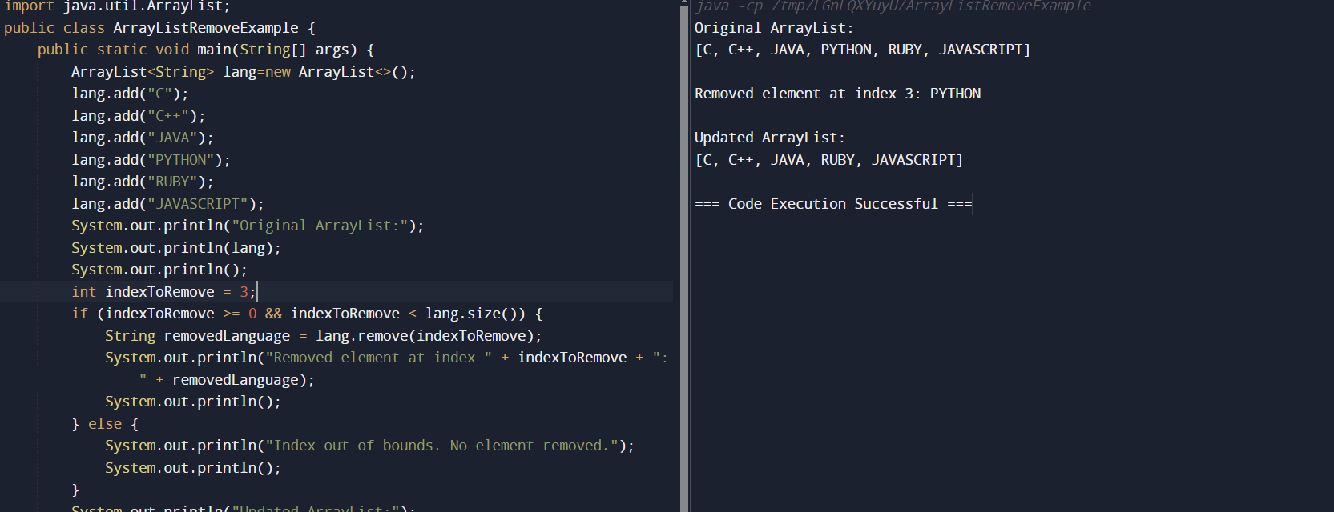

**4.** **CREATE ARRAY LIST RAJA,RAVI,RAMU,VIMAL,ROJA DEMONSTRATE ITERATE OVER AN ARRAY LIST USING FOR EACH ITERTOR ,LIST ITERATOR**

import java.util.ArrayList;

import java.util.Iterator;

import java.util.List;

import java.util.ListIterator;

public class ArrayListIterationExample {

public static void main(String[] args) {

ArrayList<String> names = new ArrayList<>();

names.add("RAJA");

names.add("RAVI");

names.add("RAMU");

names.add("VIMAL");

names.add("ROJA");

System.out.println("Iterating using for-each loop:");

for (String n: names) {

System.out.println(n);

}

System.out.println();

System.out.println("Iterating using ListIterator");

ListIterator<String> listIterator = names.listIterator();

while (listIterator.hasNext()) {

String name = listIterator.next();

System.out.println(name);

}

System.out.println();

}

}

